**User Manual**

**Introduction**

*JungleParty* is a simple application used by children to practice their counting skills.

**Preparation**:

Please make sure your computer has installed JDK. If do not, please download and install JDK.

**Version**

There are four versions, *Task1*, *Task2*, *Task3* and *ExtraCredit*.

**Steps to Run**

*Start the program*

*Step 1*

Open command line (cmd.exe), and then set the path to location of this program’s files.

Ex: If you put this program files at desktop, you can enter the follow command to change path.

*‘cd C:\Users\****lenovo****\Desktop\JungleParty\****(Version Name)*** *’*

*Note 1: Task1, Task2, Task3 or ExtraCredit can replace* ***(Version Name)****.*

*Note 2:* ‘***Lenovo’*** *should be replaced by your user name.*

*Step 2*

After finishing step1, compile *JungleParty.java* file. Use command ‘ *javac JungleParty.java ’.*

*Note: You just do the step at the first time.*

*Step 3*

For *task1, task2 and task3,* using command ‘*java JungleParty’* to run these versions program.

For *ExtraCredit*, using command *‘java JungleParty number’ to run this version program.*

*Note: For running ExtraCredit version, number should be 10 to 20.*

**Example:**

For *task1, task2 and task3*

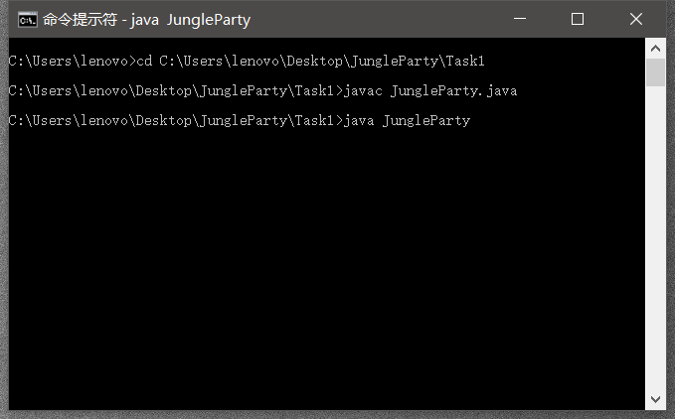

For *ExtraCredit*

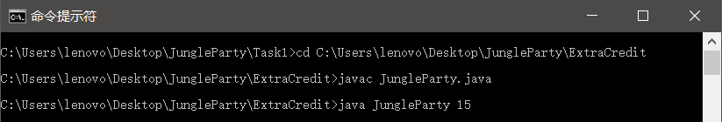

**Use the program**

After finishing the three steps above, the program is running.

*Version 1 (Task 1)*

After starting this program. You will see a window appearing. You should read the prompt message and enter the right answer at text field. Then click ‘check!’ button to check whether your answer is right.

*Version 2 (Task 2)*

This version has the same function with Task 1. However, you should choose the right answer from combo box instead entering answer at text field. After finishing your choice, click ‘check!’ button to check whether your answer is right.

*Version 3 (Task 3)*

After starting this program. You will see a window appearing. You should read the prompt message and choose the right answer from combo box. Then click ‘check!’ button to check whether your answer is right. Before you checking your answer, you can do something more. You can click a picture, and then the picture clicked will disappear. The right answer also changes. You should choose another answer. The program will check against the number of animals currently on display.

*Version 4 (ExtraCredit)*

Besides the functions of Task 3, users can set the total images by themselves in this version. You should set the total number of images at step3. Then, you just do as the version 3.

**Figure Example:**

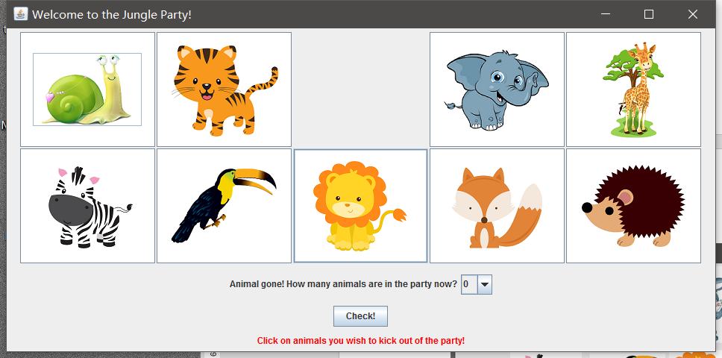

*Hint: Don not change the images in the files.*